Sunday | Monday | Tuesday | Wednesday | Thursday | Friday | Saturday | Pool Rules:  Please see pool rules regarding age of drop off and supervision required.  Swimmers of any age using a lifejacket or any other swimming aid must be accompanied, in the water, by a responsible person age 13 and up. This person must be within arm’s reach as all times.  No inflatable devices will be allowed in the pool at any time. This includes but is not limited to; water wings, inflatable rings, inflatable matrasses etc.  Pool noodles should be used for fun and not used if a patron cannot swim. A swimmer may be asked to do a swim test without the noodle. If a non-swimmer is using a noodle as a swimming aid, they must be accompanied, in the water, by a responsible person age 13 and. This person must be within arms reach at all times.
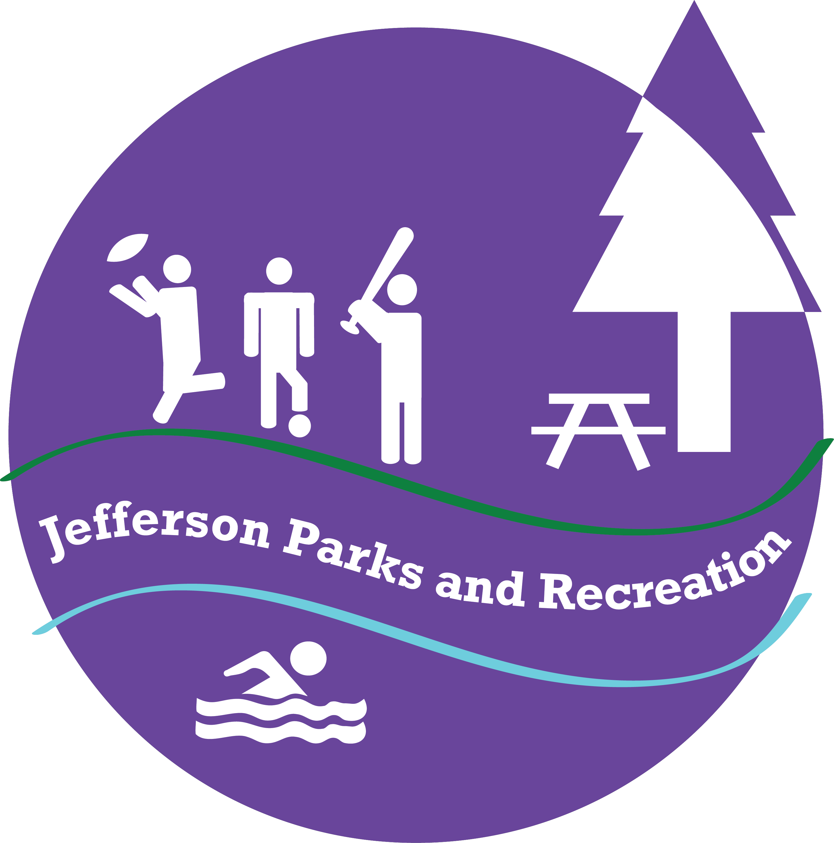  Rentals/ Closed  *Please note;  Sundays will be dedicated to group rentals. The pool will be closed on Sundays unless otherwise advertised | Swimming Lessons  9:30am-  11:50am | Swimming Lessons  9:30am-11:50am | Swimming Lessons  9:30am-11:50am | Swimming Lessons  9:30am-  11:50am | Rentals/ Closed  (Rentals must end no later than 1pm) | Rentals/ Closed  (Rentals must end no later than 1pm)
 | Lap Swim/ Private Lessons  12:00pm-12:55pm | Lap Swim/ Private Lessons  12:00pm-12:55pm | Lap Swim/ Private Lessons  12:00pm-12:55pm | Lap Swim/ Private Lessons  12:00pm-12:55pm
 | Swim Team  1:00pm-2:15pm | Swim Team  1:00pm-2:15pm | Swim Team  1:00pm-2:15pm | Swim Team  1:00pm-2:15pm | Open Swim  1:00pm-  6:30pm  *Pool will remain open until 8pm on days the temperature is over 100- please call the day of to inquire | Open Swim  1:00pm-  4:30pm
 | Open Swim  2:30pm-  5:55pm  (YMCA Swim 3-4:30) | Open Swim  2:30pm-  5:55pm  (YMCA Swim 3-4:30) | Open Swim  2:30pm-  5:55pm  (YMCA Swim 3-4:30) | Open Swim  2:30pm-  5:55pm  (YMCA Swim 3-4:30) |  | Rentals/ Closed  ( Rentals cannot start until after 4:30pm)
 | Swimming Lessons  6:00pm-  7:05pm | Swimming Lessons  6:00pm-  7:05pm | Swimming Lessons  6:00pm-  7:05pm | Swimming Lessons  6:00pm-  7:05pm
 | Water Aerobics  7:10pm-  8:00pm  *attendees must be 15 or older | $2 Lap Swim/ Private Lessons  7:00pm-  7:30pm | Water Aerobics  7:10pm-  8:00pm  *attendees must be 15 or older | Water Aerobics  7:10pm-  8:00pm  *attendees must be 15 or older | CLOSED |  | Please note; the pool may close early on days that patronage is low and the weather is poor. Please call ahead on days the weather is questionable.
*revised 6/11/2019
 | In District | Out of District
Open Swim
17 and under | $3.00 | $3.75
18+ | $3.75 | $4.25
Senior 62+ | $3.00 | $3.75
Family (up to 5 people) | $13.00 (2 adults and 2 children=$13.50) | $15.00 (2 adults and 2 children=$16)
Lap Swim
12:00pm-12:55pm (M-Th) | $3.50 | $4.00
7:00pm-7:30pm (Tuesdays only) | $2.00 | $2.00
Water Aerobics
Ages 15+ ONLY | $3.75 | $4.25
Pool Passes
Youth 10 visit punch card  (17 and under) | $25.00  (equal to about 8 visits) | $30.00  (equal to 8 visits)
Adult 10 visit punch card  (includes water aerobics) | $30.00  (equal to 8 visits) | $35.00  (equal to about 8 visits)
Youth Summer Pass  (17 and under) | $60.00  (Equal to 20 visits) | $75.00  (Equal to 20 visits)
Adult Summer Pass  (includes water aerobics) | $85.00  (Equal to about 22 visits) | $95.00  ( Equal to about 22 visits)
Family Pass (2 adults 3 children)  (water aerobics included ages 15+) | $180.00  (equal to about 13 family visits)  ($35 per additional family member) | $200.00  (Equal to about 13 family visits)  ($40 per additional family member)

Swim Lessons: Morning and Evening lessons available Monday-Thursday
In District Out of District
Swimming lessons $45.00 $50
Mini Session $22.50 $25.00
Week of July 4th $40.00 $45.00
Private lessons $25 per half hour with a minimum of 4 lessons.

Swim Team $65.00 per swimmer

10 % discount on regular lessons and swim team for members with a FAMILY PASS!

